Rapid Pilot Program 2024 – Day 1

**Day 1**  
   
  
1. Start Advanced Event Mesh   
2. Create Message Broker and Event Mesh   
3. Deploy ERP Simulator within CF Runtime ( will be provided)  
 Create Test Events  
 Consume via SAP AEM Tryout  
4. Deploy Event Dashboard within CF Runtime   
(will be provided)  
 Display/ Consume Events



# Create AEM Services

In this task, you will be creating two Enterprise AEM services, connecting them to form a mesh and verifying your mesh health.

Before starting, it will be helpful to know what cloud provider and region your SAP environment is in, and the primary cloud provider and region where your cloud applications are deployed. The value of building a mesh topology is realized when placing your AEM services close to your event producing and consuming systems. If your SAP environment is running in an on-premises data center, you will use the geographic region of that site to help select an appropriate location for that AEM service.

**Create your first AEM service:**

1. From the SAP AEM Console, open the Cluster Manager.

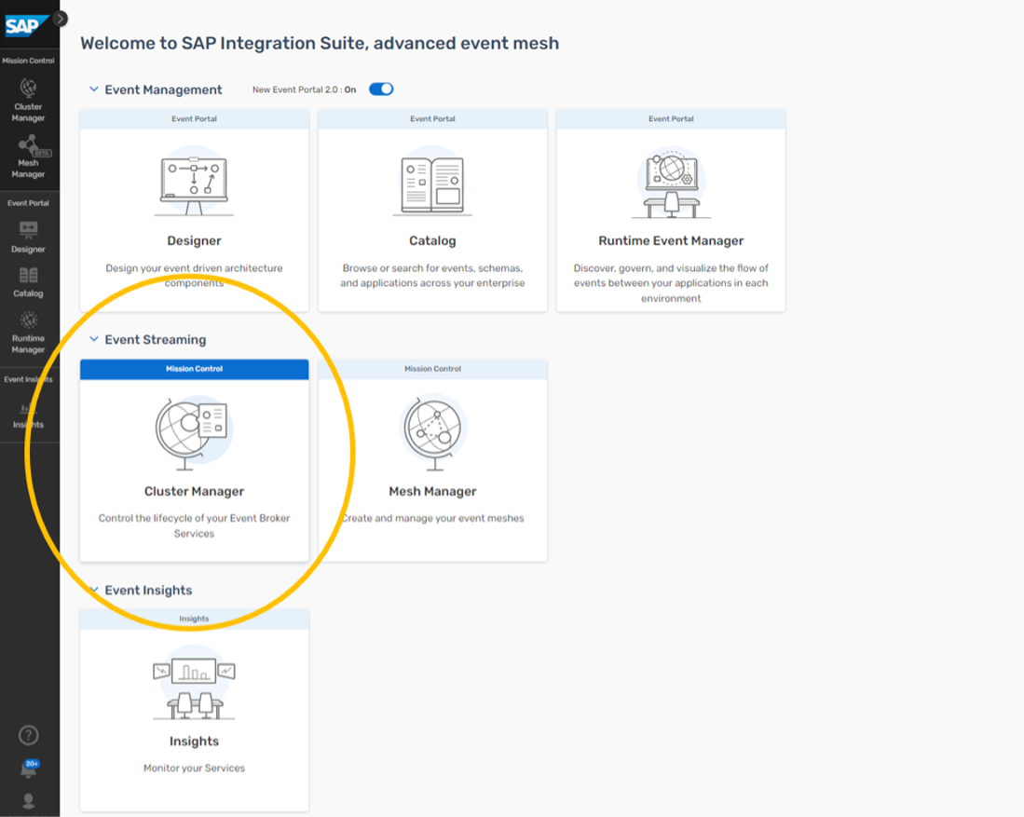

1. Now we will be creating a new AEM service

Depending on which view, you have selected, Graphical or Table based, you will see one of the following views. In either case, you can either select the “Create Service” option on the top right or the big “+” sign at the bottom.

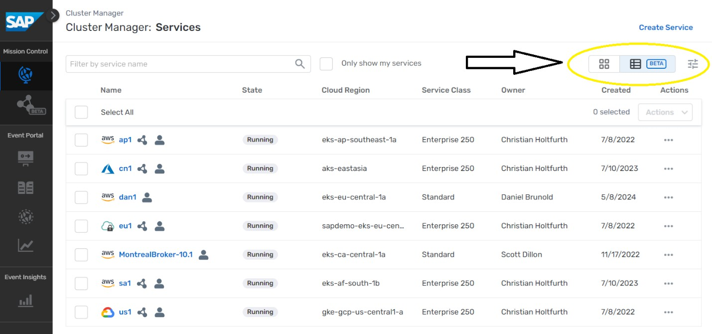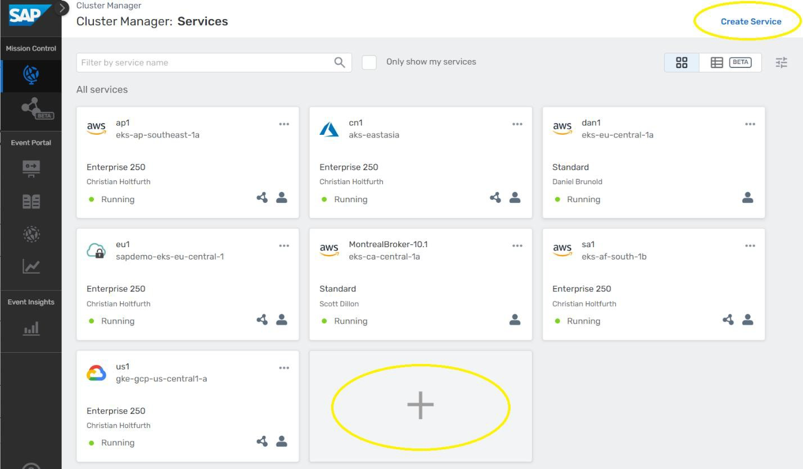

1. Name your service



### Note that service names must be unique within your account. We suggest using the mesh name you want, a hyphen, and a service ID to make it unique.

1. Pick Enterprise as the service type.

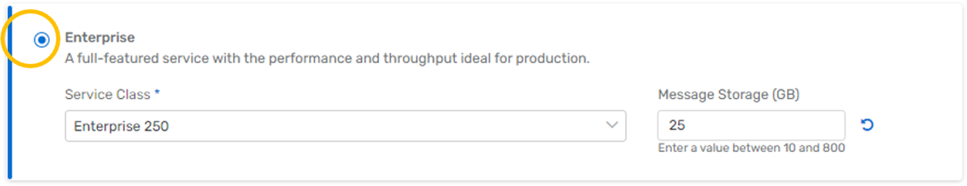

For now, keep the default service class and message storage settings.

1. Choose your cloud provider from the pull down list.

For the first AEM service, select the same IaaS (Infrastructure as a Service) provider and region where your SAP is running, the RISE provider and region where your SAP Cloud is running, or for an on-premises SAP pick a cloud provider and region closest to where your data center is located.

For the second AEM service, select the same provider and region where your cloud applications are located. If you have several, pick one that is distant from your SAP environment (you can expand your mesh later to include additional cloud locations).

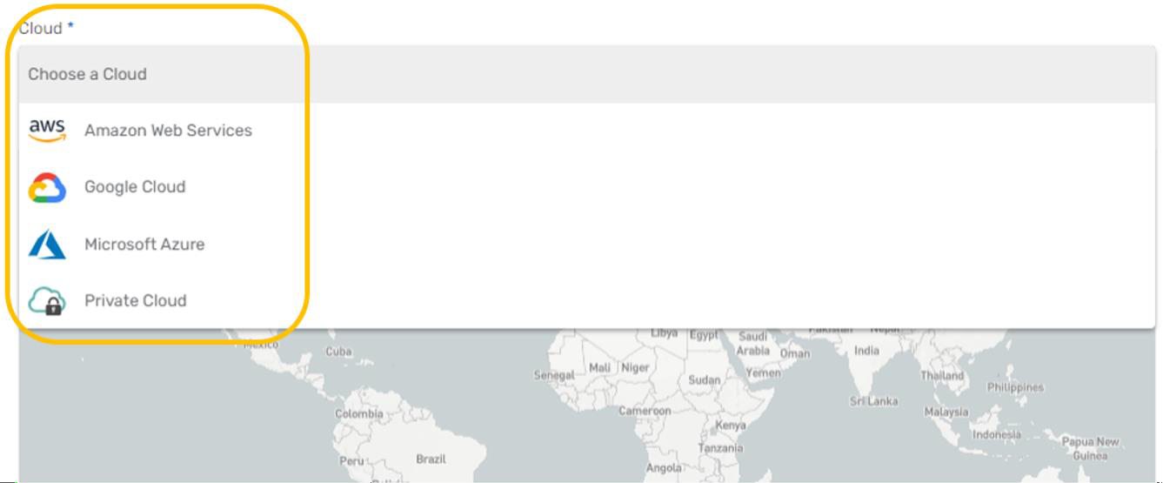

### Note that you can also request buildout of a private cloud region on-premises at your data center later, but for now please select the best matching cloud provider.

1. Click the Select Region box inside the map and select your cloud region.

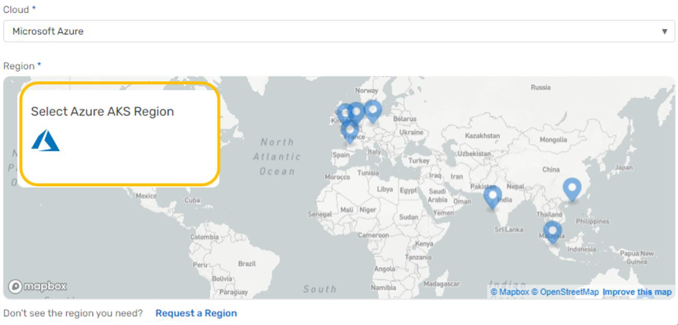

This example shows selecting Azure as the provider and East US 2 (Virginia) as the region:

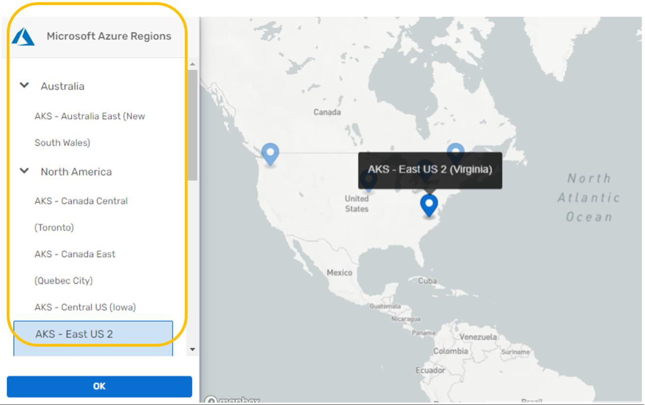

Please substitute your best provider and region as you make your selection and click OK.

1. Keep the Default Broker Version Selection



1. Click Create Service to launch your AEM service.

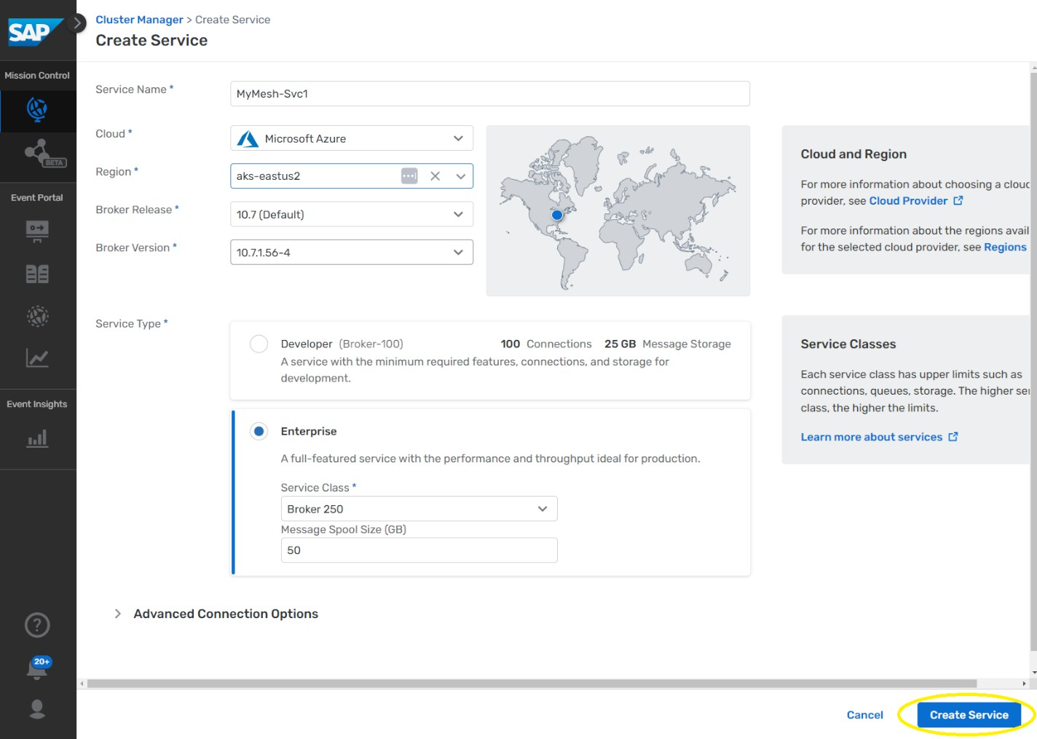

You can proceed with the next step while your first AEM service is starting.

1. Repeat steps 2 through 8 for your second AEM service.

Substitute the name (Svc2) along with the appropriate cloud provider and region.

**IMPORTANT - For your second AEM service:**

Select a Different Region for the 2nd service (with the same or different cloud provider).

Once the services finish starting up, you should see the 2 services you created and you can click on each of them to see the status.

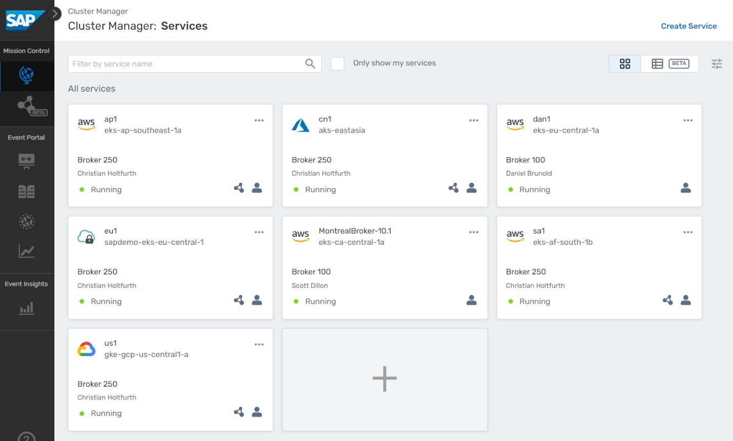

For example, clicking on our MontrealBroker, provides me with the following view: From this view, I can see for example that I have 79 SMF connections open.

Question: Do you know what SMF stands for?

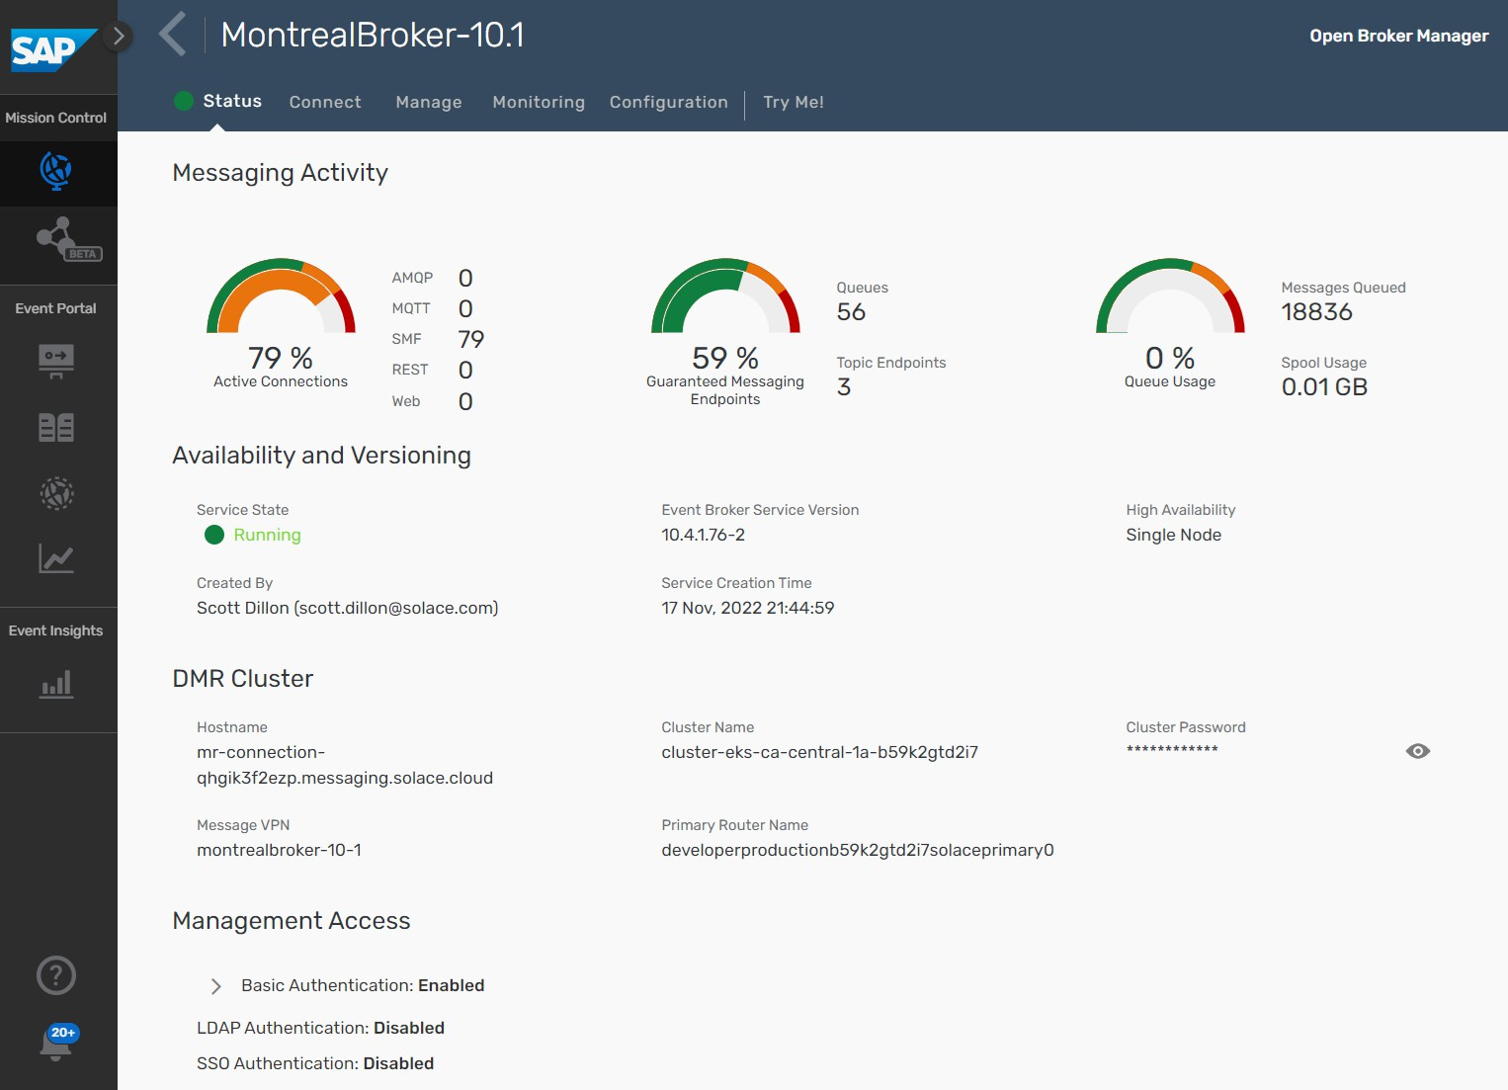

# Build an Event Mesh

1. Define a new mesh. From the SAP AEM Console, open the Mesh Manager:

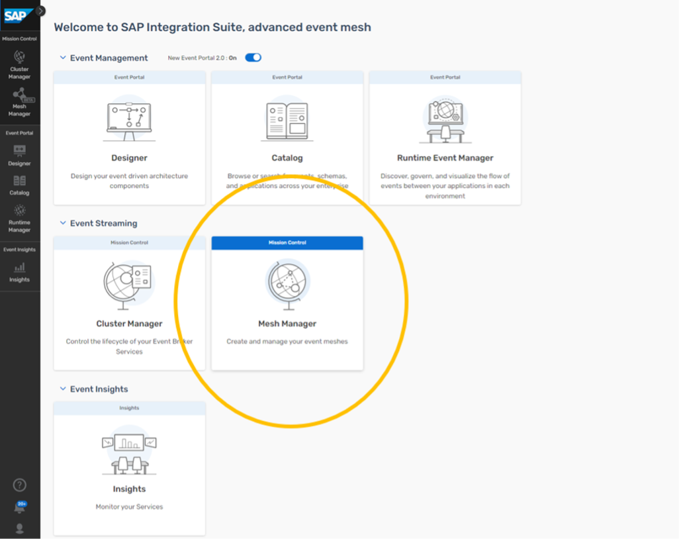

Click the Create Mesh

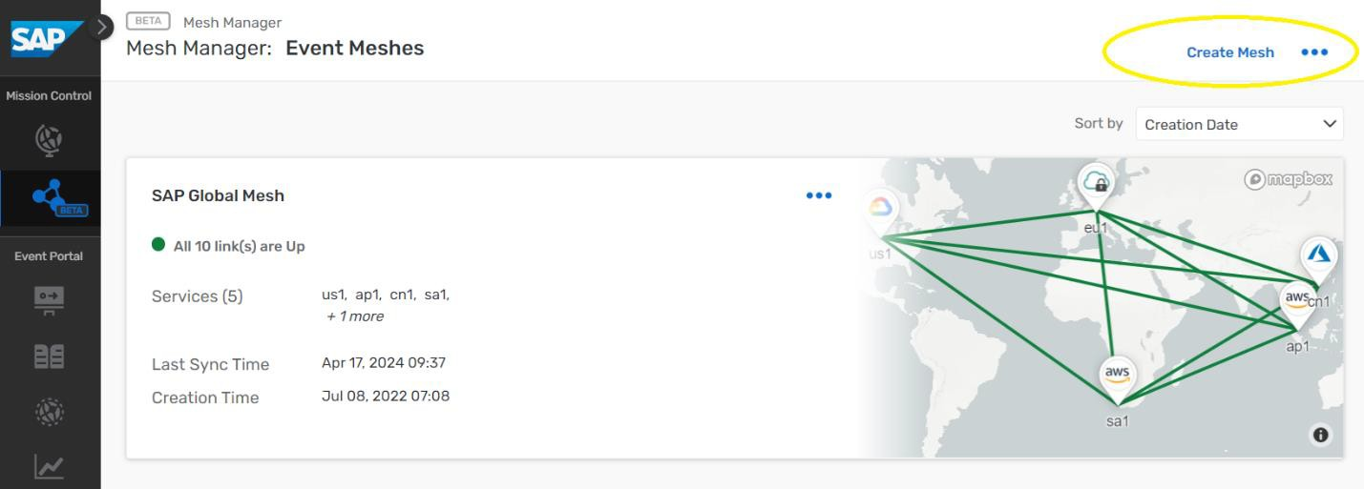

Enter the same mesh name used when defining your AEM services.

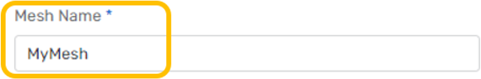

1. Add your AEM services to the mesh.

Click Add Service, then use the pull down search box to find and select your first service

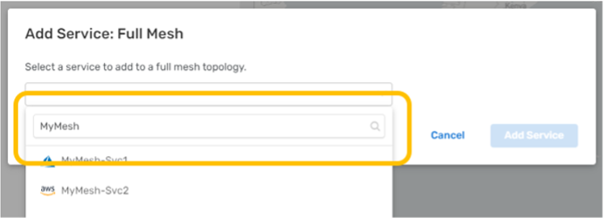

Click Add Service in the dialog to complete the action:

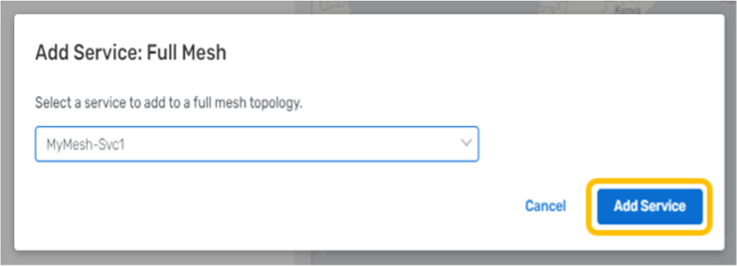

Click Add Service again and add your second service.

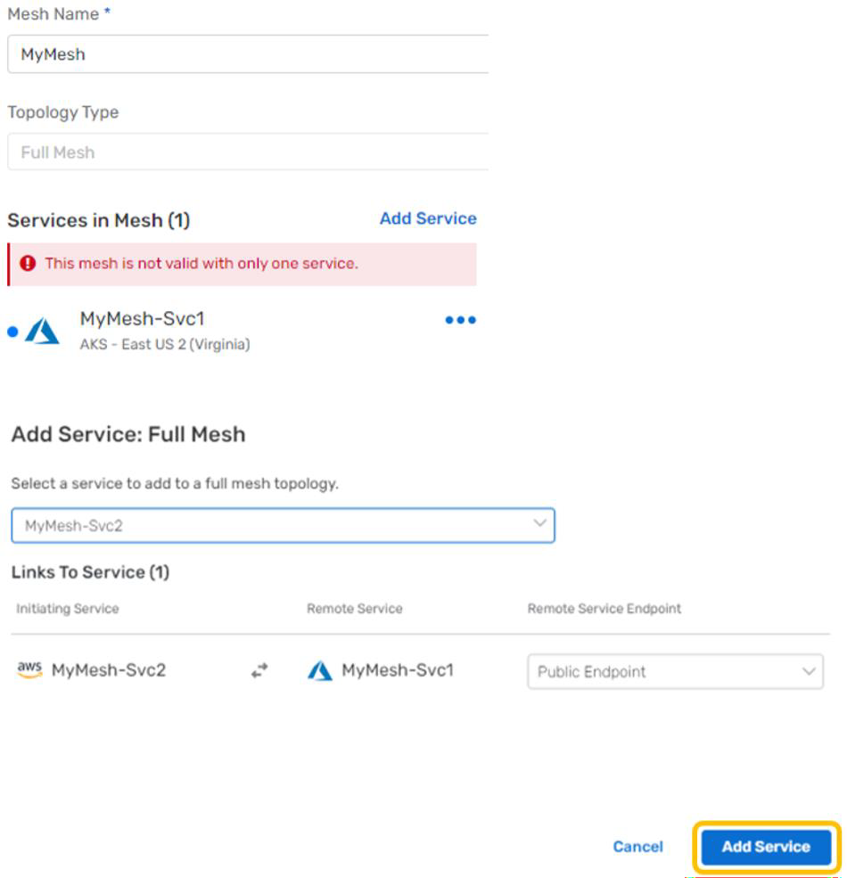

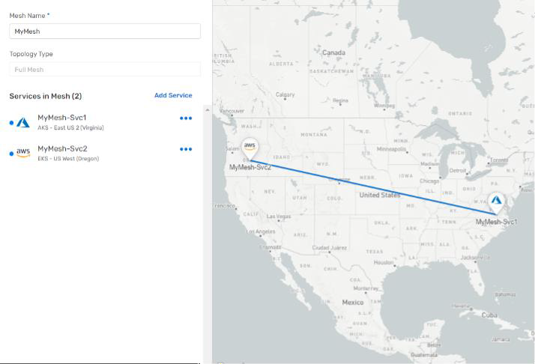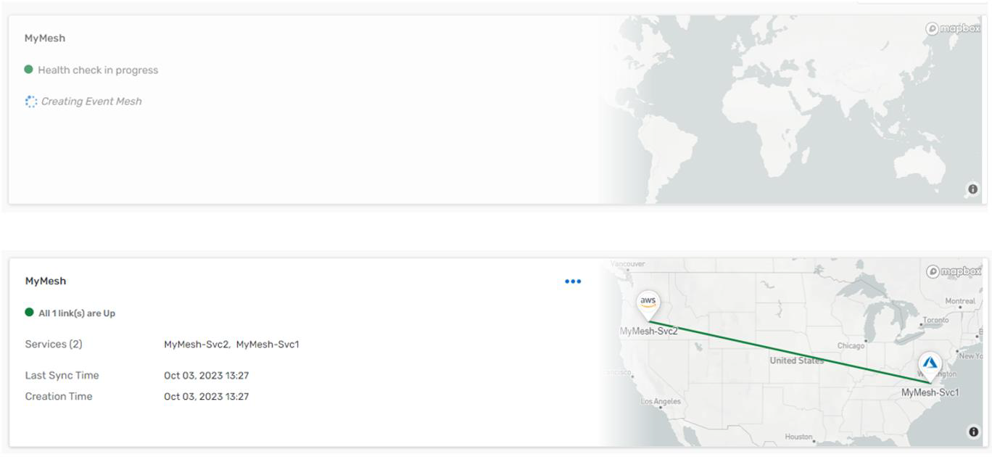

1. (**Optional**) Run a health check on your event mesh. From the Mesh Manager, click on your event mesh to open the status page :

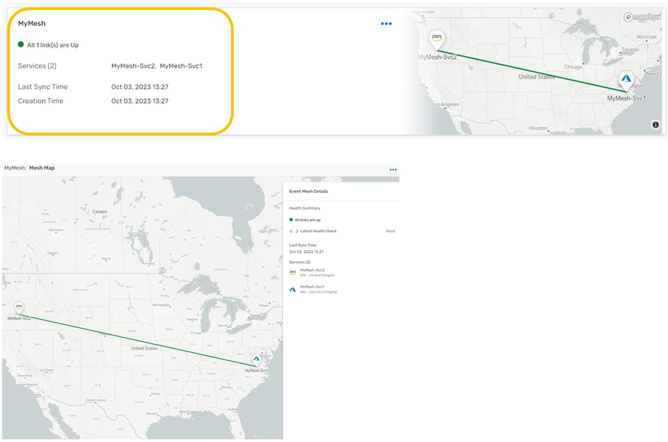

Expand the Latest Health Check and click Run Health Check action:

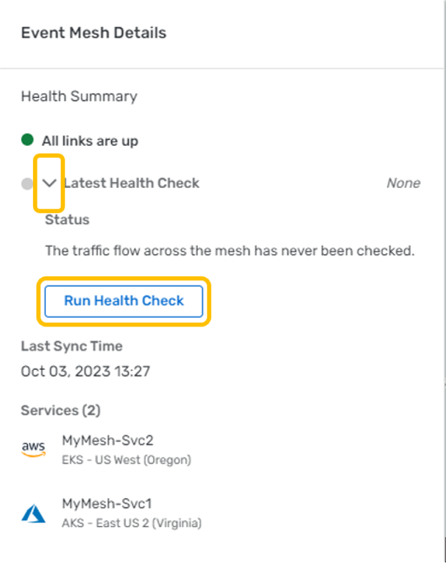

The health check progress is shown, followed by the health check status:

